
ALL INDIA STATE BANK OFFICERS’ FEDERATION
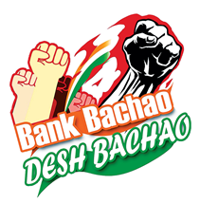
(Registered under the Trade Unions Act 1926, Registration No: 727/MDS)
Central Office: State Bank Buildings, St. Mark’s Road, Bangalore-560 001
Registered Office: 22, Rajaji Salai, Chennai- 600 001

CIRCULAR NO. 68 DATE: 15.11.2022
TO ALL AFFILIATES

Dear Comrades,

12th Triennial General Council of SBIOA Chandigarh Circle
A stupendous exhibition of Unity, Strength and Solidarity

12th November 2022, Indradhanush Auditorium, Panchkula, Haryana was the destination of over 2000 officers of SBIOA, Chandigarh Circle to attend the 12th Triennial General Council, who came from every nook and corner of states of Haryana, Punjab, Himachal Pradesh and UTs of J&K, Ladakh and Chandigarh.
2. The event witnessed the participation of leaders from all over the country. They were
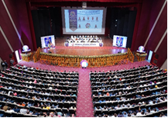 | 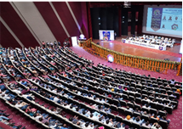

welcomed to the venue by traditional folk dance teams from Punjab, Haryana, Himachal Pradesh and Jammu & Kashmir. The whole area was decorated with banners and posters of leaders and revolutionary slogans. At the entrance to the auditorium, a tunnel namely the “Free Expression Tunnel” was installed to enable members to express their thoughts freely in the space provided. Many of the comrades expressed their feelings with marker pens, graffiti art and quotes. One of the major demands was a 5-day work week and work-life balance.
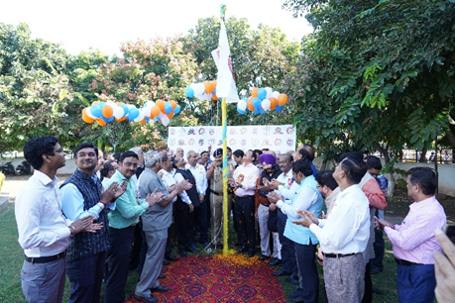
3. The event started with the hoisting of the Association flag by Com. Rupam Roy, Chairman of the Federation, Com. Sanjay Sharma, President of Circle association and Com. Deepak Kumar Sharma General Secretary of the circle, who was also President of the Federation along with all leaders from other affiliate circles and the undersigned. As a mark of the event, hundreds of colorful hot-air balloons were released by the leaders and activists of the circle amidst slogans “BankBachaoDeshBachao”, “AISBOF Zindabad”, “SBIOA Zindabad” that reverberated across the entire area.
4. Team of anchors on the stage viz. Com. Dinesh Devghariya, Com. Ram Kishor Poddar and Smt. Monika Arora welcomed all the leaders and members and requested the participants to download the Facebook lite app and subscribe to the social media “BankBachaoDeshBachao” page.
5. Com. Rajiv Sirhindi, DGS, Chandigarh Circle welcomed Com. Sanjay Sharma and Com. Deepak Sharma, President and General Secretary of the Circle Association, on the dais amidst 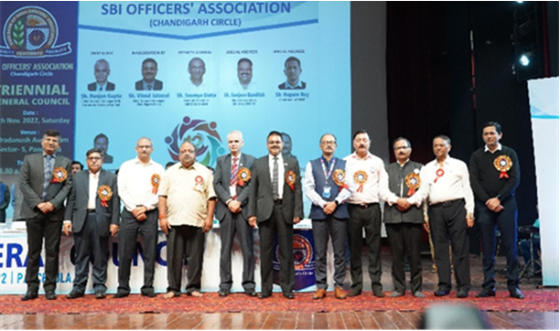thunderous slogans and applause from the audience. All the dignitaries were escorted to the dais by EC members of the Circle association and were welcomed on the dais with a shawl and sampling by the President and General Secretary. The dignitaries on the dais included Com. Rupam Roy, Chairman AISBOF, the undersigned, and Presidents and General Secretaries of all Circle affiliates. The distinguished guests were Shri Ranjan Gupta, Chief General Manager (HR) CC Mumbai, Shri Vinod Jaiswal, Chief General Manager, Chandigarh Circle, Com. Sanjeev Bandlish, General Secretary NCBE & Convener, UFBU, Com. Amar Pal Ex GS, Chandigarh Circle & Ex-President of the Federation, Shri Sumit Kumar Phakka GM NW-1, Shri Sujit Kumar GM NW-2, Shri Ajay Kumar Jha, GM NW-3. Many Senior Executives of the Bank, retired office bearers, trade union veterans, representatives of AIBOC Chandigarh Tri-city, Federation EC members and other affiliates and Bank officials of Chandigarh Tri-city also participated in the occasion.

The office bearers of the affiliate Circle Associations whose presence made the occasion special were:

Com. Nilesh Radia  Com. Pinakin Brahm Bhatt | President  General Secretary | Ahmedabad
Com.V.N.Nagesh  Com. Kiran S. Mathad | President  General Secretary | Bangalore
Com. Madan Kishore Jain  Com.Sanjeev Sabhlok | President  General Secretary | Bhopal
Com. Arun Kumar Bishoyi | General Secretary | Bhubaneswar
Com.P.Nalla Perumal Pillai  Com.R.Balaji | President  General Secretary | Chennai
Com. Jatinder Pal Singh Sethi | President | Delhi
Com.S.Appa Swamy | President | Hyderabad
Com. Vinay K.Bhalla | General Secretary | Jaipur
Com. Biju T | President | Kerala
Com. Asitava Kundu | President | Bengal
Com.A.K.Agnihotri | President | Lucknow
Com.Mohan Shamji Gohil  Com.Manohar Baboo Devrukhkar | President  General Secretary | Mumbai Metro
Com. Udaram Hedaoo  Com. Bhushan Mahajan | President  General Secretary | Maharashtra
Com. Amaresh Vikramaditya | General Secretary | Patna

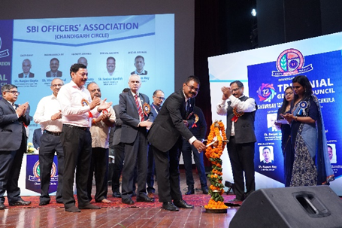
6. The function was inaugurated with the lighting of the ceremonial lamp by Shri Vinod Jaiswal, CGM Chandigarh Circle and other dignitaries. An ethereal atmosphere was created with the flute played by Sh. Pritam Chandel was in the background and was followed by Ganesh Vandana. Com. Kumar Sachin and Com. Shailesh Varma sang a medley of songs and ended with the popular song “Bank Bachao Desh Bachao”.
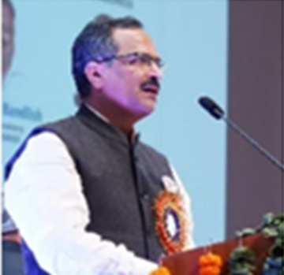
7. In his welcome address Com. Deepak Kumar Sharma, General Secretary, SBIOA Chandigarh Circle greeted all the dignitaries, guests and delegates who were part of the 12th Triennial General Council. He shared that many officers of the circle were on duty due to the conduct of the assembly election in Himachal Pradesh, Panchayat Election in Haryana, National Lok Adalat, the JAIIB exam and the Clerical recruitment exam. He expressed happiness that despite all these factors venue is witness to the biggest ever conglomeration of 2000+ bank officers in Panchkula and appreciated the efforts of membership for proudly showcasing the strength, unity, and commitment of the officers' fraternity to the entire country. He congratulated the members, especially lady members, who had assembled from the far-flung areas of the Circle which comprises three states (Haryana, Himachal Pradesh and Punjab) and three UTs (Chandigarh, Ladakh and Jammu & Kashmir). He thanked the management for providing assistance to all staff members during Covid pandemic. He congratulated all the staff for their contribution to achieving the highest historic profit during the previous quarter and previous financial year. He requested all the members to always showcase good conduct, inside as well as outside the Bank, to protect & build the positive image of the Bank. He also cautioned the members not to post any issues/problems on social media which may damage the image of the bank and advised them to share the issues through association and federation for satisfactory resolution through structured forums. He insisted that to compete with other banks knowledge updation of the members is a must, which helps in acquiring a business and providing the best customer service. He shared the pain points of the members that many times Customer service gets affected due to technical glitches in the branches. He cautioned against the practice of mounting pressure on huge targets which may lead to unethical means to achieve them and advised members to carry out the work keeping the S-T-E-P-S in mind. He shared that calling the officers on Sundays/holidays and public humiliation and disrespect from higher-ups had affected the morale of officials, affecting them mentally and physically. To avoid mental stress, he advised us not to hide the truth and be there for each other in times of need. He also advised us to help and work together to keep the bank’s interest first to have a better life for all. He requested Com. Bandlish for necessary measures to remove the hurdles in 5 day work week, wage negotiations and resolve them at the earliest. He concluded with slogans SBI Zindabad, AISBOF Zindabad, SBIOA Zindabad and Membership of SBIOA Chandigarh Circle Zindabad.
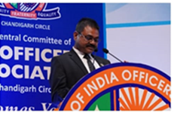
8. Shri. Vinod Jaiswal, Chief General Manager, Chandigarh Circle in his inaugural address thanked the Circle membership for their contribution and collective efforts for highest ever profit of SBI. He stressed improvement in market share, particularly SME and Agricultural business. He advised the staff to make all efforts for mobilising deposits for the bank. To have positive results and improvement in the bank business the only mantra is world-class customer service. The Association and the management are the two sides of the same coin and it is the need of the hour to work together for the development of the bank as well as the staff members. He pressed for timely compliance at the bank level as well as the Government level. He also advised following the bank’s instructions meticulously. For the success of our organisation everybody should contribute and work together smartly. Everybody should always be disciplined, be ethical and should own their work. Everybody should take utmost care not to tarnish the image of the bank through social media. He wished good health and happiness to all.
A book namely companion-2022 was released by all the dignitaries on the dais. On this occasion, Com. Priyvrat, Circle Vice President, announced that the website of the circle association ‘www.sbioacha.org’ is revamped and the members will be able to book the guest houses maintained by the SBIOA Chandigarh circle through the online booking facility from 01st Dec 2022 onwards.
9. The Circle Association took an opportunity to felicitate the erstwhile leadership. Former General Secretaries of SBIOA Chandigarh Circle Com. Amar Pal, Com. Vijay Magon, Com. D K Sharma, Com. D P S Chabra as well as eABOA Unit Patiala Com. Amar Singh, Com. B C Bassi, Com. Pramod Sharma and Com. J P Gupta was felicitated with a shawl and sampling.
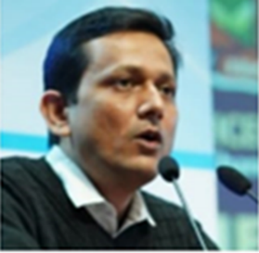
10. Com. Rupam Roy, General Secretary of North East Circle and Chairman, AISBOF in his special address advised the members and circle leadership to discuss all the issues particularly HR related in the business session. He also advised bringing those issues to the Federation for further discussion and follow-up with the management for early resolution. He advised narrowing the gap between members and the management.
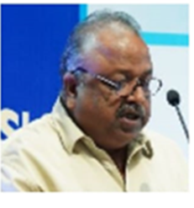
11. Com. Sanjeev Bandlish, General Secretary NCBE & Convener UFBU in his special address stated that to oppose the privatization of Public Sector banks we marked our protest by calling strike calls whenever needed due to which the Government deferred the bill. The Government’s intention was to merge banks to reduce losses. However, all PS banks have come out from losses and presenting healthy balance sheets. Due to the strong opposition from UFBU, the Govt. could not introduce the bill in Parliament, but we should not believe that in the future the Govt. would not try to introduce it once again. We should always be ready with agitation programs including strike calls. He assured the members those residual issues of recent bipartite to be addressed before moving to the next wage revision talks. He talked about the updation of pension. He thanked the past leadership for their contribution and vision.
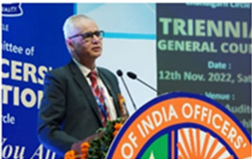
12. The Chief Guest of the occasion, Shri. Ranjan Gupta CGM, HR Corporate Centre Mumbai and Chief Guest of the function expressed his sympathy towards the staff who lost their lives during the Covid pandemic and paid his tribute. He thanked the leadership for sharing the concerns of the management with the members. He expressed his happiness for the large gathering to attend the Triennial General Council. The vision of the Federation and Management should be able to reach the members and we should use the right person in the right position to enhance productivity resulting in strong growth of the bank. He opinioned that there is a disconnect between the staff appointed before and after 2010 which is to be integrated into the mainstream for better coordination and improvement in work culture. He advised the staff to be cooperative towards our own retired people. He expressed his satisfaction with the contribution made by the undersigned to this great organization and wished him all the success for his next phase of life.
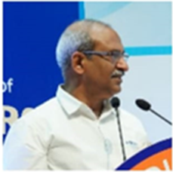
13. The undersigned in his keynote address shared his experience with the management and good relations with Shri O.P.Mishra, DMD (HR) & CDO and Shri Ranjan Gupta, CGM (HR), who were doing their best to ensure work-life balance in a letter and spirit. While reminiscing the journey with Com. Deepak Sharma expressed that by working in tandem, the Federation leadership could successfully flag and resolve several issues at the Corporate Centre. He expressed his happiness that as per the succession plan of the Circle Association the younger generation is taking over the responsibility of the trade union movement in days to come. He insisted that to have good coordination within us we have to learn to respect each other including contractual employees, the same way as we do in our family. He expressed delight at the management’s decision that the recent enhancement in Furniture & Fixture eligibility on the day of the Q-2 results is a recognition of the hard work done by the officials. He was of the opinion that Public Sector Banks are brand ambassadors of social harmony. He once again requested CGM (HR) to look into the disparity between the salary of officers and award staff for early resolution and wished that the dignity and self-esteem of the officer’ are to be protected. He expressed his satisfaction that the agitation program to save the banks from privatization through the ‘BankBachaoDeshBachao” movement has touched the pulse of the nation. He cautioned the members while using social media that each one should be vigilant and take responsibility for protecting the bank’s image. He concluded his address with the trademark slogan “BankBachaoDeshBachao”.
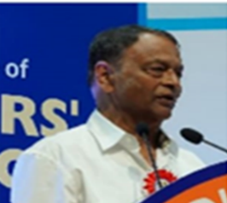
14. Com. Amar Pal Ex-General Secretary of Chandigarh Circle and Ex-President of the Federation expressed his happiness that the future Federation leadership is with Chandigarh Circle. He advised the leaders to fight against Privatization and other issues by declaring an indefinite strike if need be. He requested the leadership to take up the issues of pensioners. He had the opinion that the interest rates for all staff loans should come down drastically.
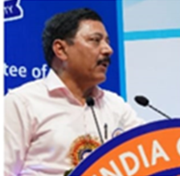
15. The inaugural session concluded with a Presidential address and vote of thanks proposed by Com. Sanjay Sharma, President, SBIOA Chandigarh Circle followed by a rendition of the National Anthem.

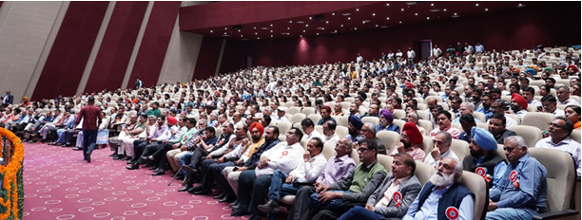
We congratulate our Chandigarh affiliate for the super all-round show that instilled confidence amongst the rank and file to repose the utmost trust of the Circle Association leadership.

With greetings,
Yours Comradely

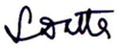
(Soumya Datta)
General Secretary

At the Service of Members for more than 5 Decades
General Secretary: 9830044737, Kolkata-033-22130154, Fax: 033-22101684
Bengaluru: (Dir) 080 2221 1006 General: 25943132 Fax: 2221 4959
Email: aisbofbangalore@gmail.com Web: www.aisbof.org

