
ALL INDIA STATE BANK OFFICERS’ FEDERATION
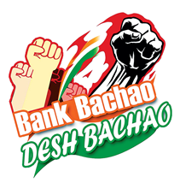
( Registered under the Trade Unions Act 1926, Registration No: 727/MDS)
Central Office: State Bank Buildings, St. Mark’s Road, Bangalore-560 001
Registered Office: 22, Rajaji Salai, Chennai- 600 001

CIRCULAR NO. 56 DATE: 28.07.2022
TO ALL OUR AFFILIATES

Dear Comrades,
SBIOA, Jaipur Circle – 3rd General Body Meeting
A Grand Exhibition of Solidarity

23rd July 2022, witnessed a gala demonstration of camaraderie, solidarity and passion as over a thousand members of SBIOA (Jaipur Circle) congregated at "Sanjeev Gupta Manch - Deep Smriti Auditorium” in the Pink City – Jaipur along with executives of the bank, veteran leaders, well-wishers, retired executives, members of other fraternal organizations to celebrate the 3rd General Body Meeting of the Circle. The rhythmic beats of drums and the passionate rendition of organizational slogans enthralled the environment. The dais was dedicated to “Com Sanjeev Gupta” in recognition of his passionate trade unionism, who passed away during the Corona pandemic.
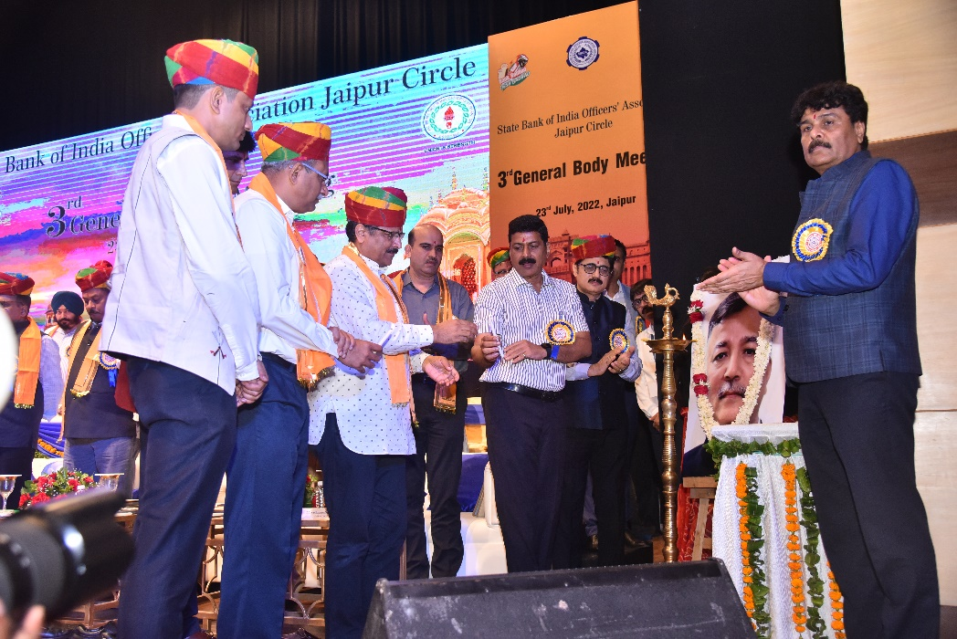
2. The meeting commenced by hoisting of the flag of SBIOA Jaipur Circle by the AISBOF Leadership - Com Rupam Roy - Chairman, AISBOF Com. Deepak Kumar Sharma- President, Com. Ramavtar Singh Jakhar – President of Circle, Com Vinay Kumar Bhalla - General Secretary of Circle and the undersigned in the august presence of the local management functionaries, the Presidents and General Secretaries of various Circle Associations and other office bearers. The venue reverberated with thunderous slogans, raising the passion of trade unionism in each present on the occasion. More endearing was the significant presence of youth, demonstrating the confidence and the trust of youth in the trade union movement. An eye-catching documentary highlighting the illustrious journey of the Association, the struggle, achievements and diverse activities were screened which were appreciated by one and all. The audience was called upon to download Facebook Lite App, and invite all their acquaintances to our FaceBook Page #BankBachoDeshBachao to give momentum to the movement.

3. The event commenced on a passionate note with the #BankBachoDeshBachao slogan reverberating in the auditorium continuously. Com Ramavtar Singh Jakhar, President and Com. Vinay Bhalla, General Secretary of Circle association welcomed Shri Bhupendra K Dak, IPS, Director General Prisons, Rajasthan Police, Chief Guest, Shri Rajesh Mishra, Chief General Manager of the Circle and General Managers of the Circle & CAO, Circle Development Officer & DGM Shri Bhupendra Joshi, President and General Secretary of Federation, office bearers of other Circle Associations and Pensioner Association. The event formally commenced with Ganesh Vandana, followed by the mesmerizing presentation of Rajasthani folk Kalbelia Dance by Nathu Lal Group of performing Art and lighting of lamps by dignitaries. A short documentary on the journey of SBIOA Jaipur Circle was screened. A brilliantly scripted and directed ‘welcome video” highlighting the city of Jaipur and the activities of the Circle Association was screened followed by equally captivating short clips on the #BankBachaoDeshBachao movement.
4. After paying floral tribute to the portrait of Late Com Sanjeev Gupta, Jaipur Circle Deputy General Secretary and state secretary of AIBOC, Rajasthan, the ceremonial lamp was lit by all the dignitaries present on stage.
5. The following office-bearers of various affiliates were present:
Com Nagesh Varkur Nagraj | President | Bengaluru
Com Srinivas Shroff Kanivehalli | General Secretary | Bengaluru
Com. Asitava Kundu | President | Bengal
Com. Madan Kishore Jain | President | Bhopal
Com Amitava Das | President | Bhubaneshwar
Com Arun Kumar Bishoyi | General Secretary | Bhubaneshwar
Com. P. Nallaperumal Pillai | President | Chennai
Com. Jatinder Pal Singh Sethi  Com. Sushil Ahuja | President  General Secretary | Delhi
Com. S. Appaswamy | President | Hyderabad
Com. V.K. Premachandran  Com. G.R. Jayakrishnan | President  General Secretary | Kerala
Com. A.K. Agnihotri  Com Pawan Kumar | President  General Secretary | Lucknow
Com. Mohan Shamji Gohil  Com. Manohar Baboo Devrukhkar | President  General Secretary | Mumbai Metro
Com. Udaram Hedaoo  Com. Bhushan Mahajan | President  General Secretary | Maharashtra
Com. Amaresh Vikramaditya | General Secretary | Patna

6. Apart from the Presidents and General Secretaries, the event was graced by officer bearers from other affiliates and AISBOF Secretariat. Befitting the legacy of the Circle Association, retired office-bearers, and representatives of AIBOC & AISBOF were felicitated.
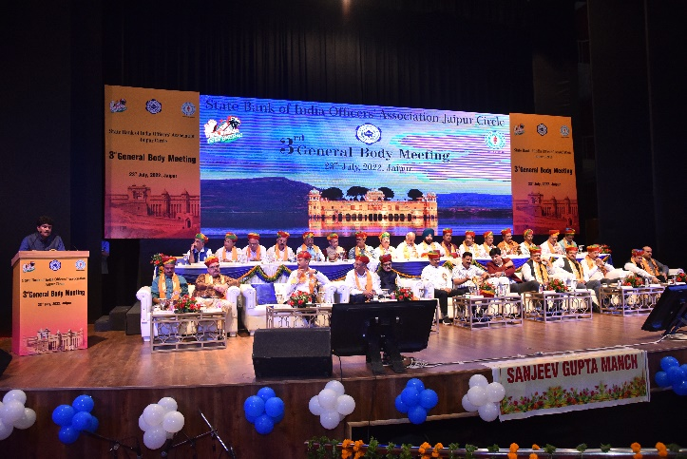
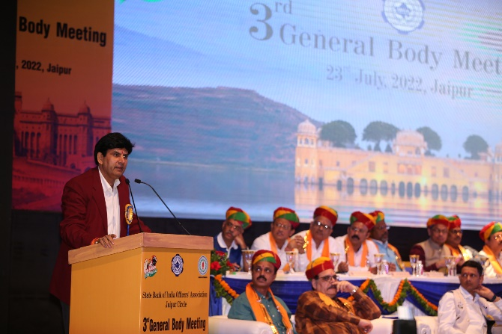
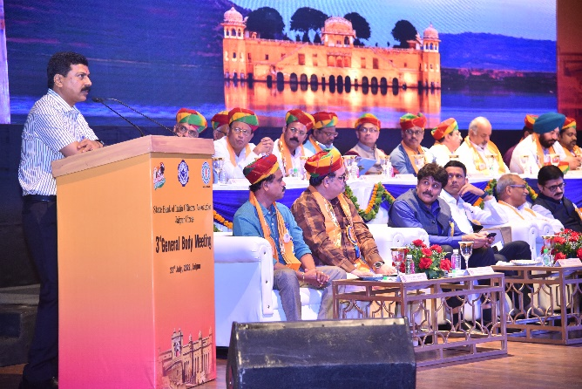
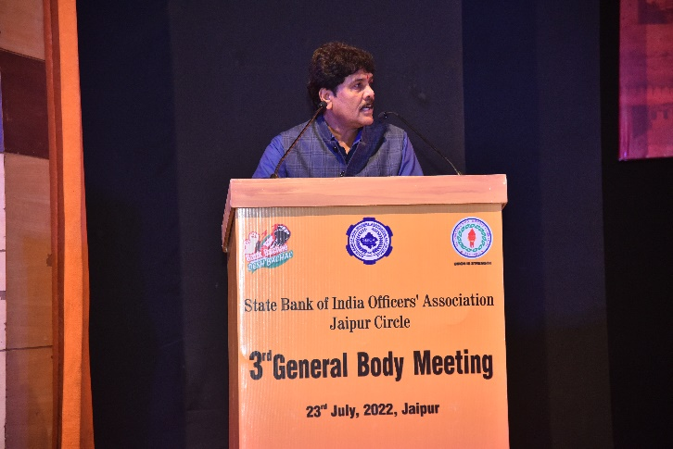
7. Com. Vinay Kumar Bhalla, General Secretary, Jaipur Circle, welcomed the delegates. In his address, he appreciated the positive attitude of Shri Rajesh Mishra, CGM who has always been open to suggestions and has provided easy access. He also said that issues pertaining to officers’ fraternity were being flagged regularly to Circle Management and many of them have been addressed by the management. He further said that he was hopeful that the issues remaining will be resolved at the earliest. He thanked the members (more than 1200) and graced participants despite incessant rains, demonstrating a tremendous show of unity and solidarity. He also raised the issue of the shortage of staff in the Circle despite which the Circle achieved exemplary growth in all aspects of the bank. He expressed concern that the shortage of Scale I and II officers of about a thousand were a matter of worry which has created pressure on the frontline staff.
8. Com Ramavtar Singh Jakhar, in his presidential address, recalled the warm relationship of the CGM and other Executives had with the Association and thanked and welcomed all the guests and members for making the event a huge success. He emphasized the need for unity. He urged the members to take part in all organizational activities for achieving a decent wage revision. He welcomed the vibrant officers from Jaipur Centre and officers who had come from far-flung areas like Jodhpur, Bikaner, Kota, Udaipur and Alwar Modules for the grand success of the General Council meeting.

9. Shri Bhupendra Dak IPS, Director General Prisons, Rajasthan Police, and Chief Guest of the meeting, congratulated and thanked the officers’ fraternity for the yeoman services rendered by them during a pandemic. He appreciated the Circle Association for many of its initiatives and the active participation of officers. He advised the bankers to become stronger and be on the frontline in serving the people of the country. He urged bankers to be positive in their mindset and extend service to the customers and keep themselves free of tension.
10. Shri Rajesh Kumar Mishra, CGM, Jaipur Circle in his inaugural address recollected the cordial relationship the Circle Association has with Circle Management. His address profoundly inspired the audience as he dwelled on several issues concerning the bank, work-life balance, and the importance of being human. The entire house spontaneously applauded when he said that all of us must remember at every moment that we were all human beings. He acknowledged the contribution of the Association to achieving countless benefits for the entire fraternity and all the executives, who were present on the occasion, are members of the association for more than two decades. He stressed the importance of Customer Service in the Banking Sector. He stressed ranking in Customer Service among all circles. While he touched upon various aspects of banking, he concluded that we must all aim at doing something for society to gain respect for ourselves in society. He also touched upon the issue of customer service, compliance, and the threat of the Bank losing its premier position in the wake of the merger of HDFC and HDFC Bank.
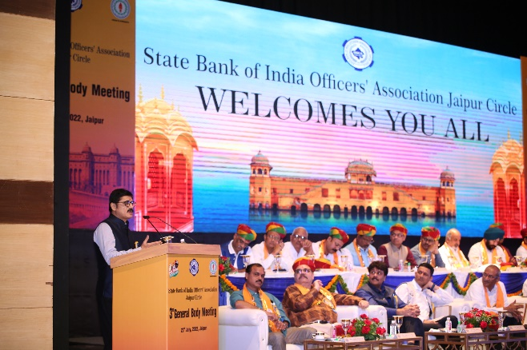
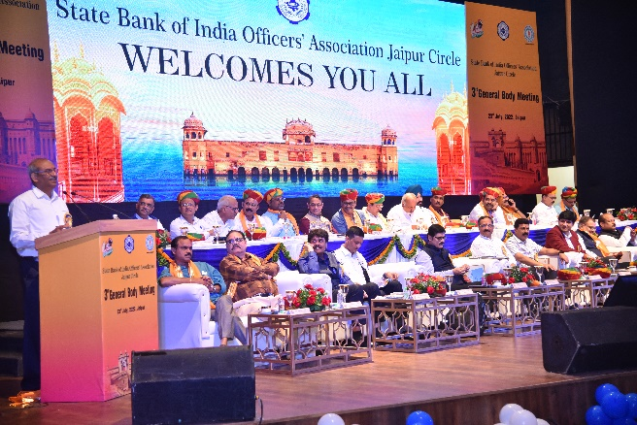
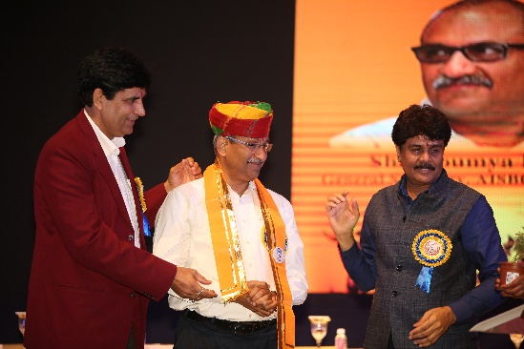
11. Com. Rupam Roy, Chairman, AISBOF in his brief address appreciated Jaipur Circle for the vibrancy and the enthusiasm displayed during the last Triennial at Guwahati. He wished the success of the 3rd General Body Meeting of Circle Association. He appealed to officers to raise voice against Bank Privatization strongly.
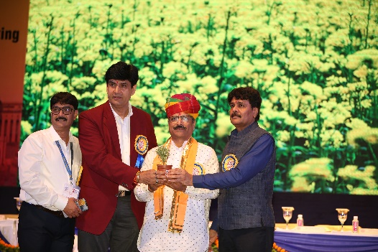
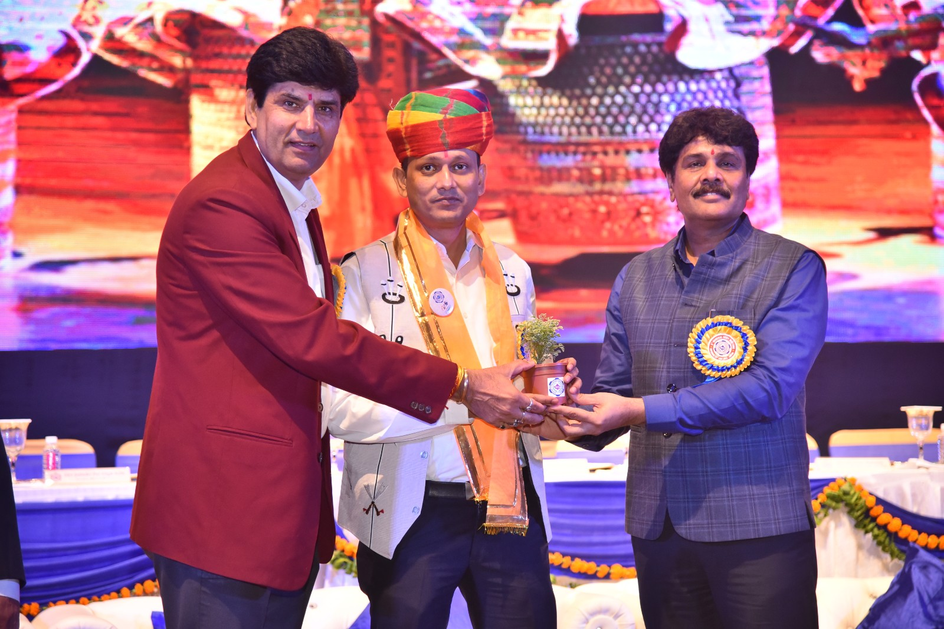
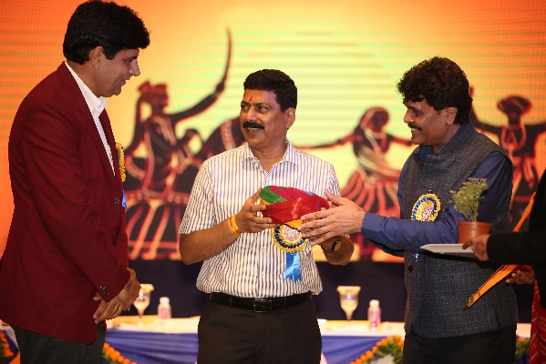
12. Com. Deepak Kumar Sharma, President of AISBOF congratulated Jaipur Circle officers who gathered in large numbers to witness the historic event. He appreciated officers working in the circle which had reflected in achieving excellence in all areas. He called upon members to be united to resolve the pending issues. He touched upon the issues like bank privatization, the game-changing movement #BankBachaoDeshBachao conceptualized by AIBOC, residual issues of 8th Joint Note, 5 Day Week, Pension updation, Scrapping of NPS, shortage of staff, work-life balance, compliance, staff accountability etc. He also said that efforts are being made to resolve pending residual issues before the commencement of the next wage negotiation. He assured that the Federation will ensure protecting self-respect of its members. He also stressed the need for improvement in internal customer service and assured the circle leadership all help in resolving the issues flagged by the General Secretary of the Circle Association during his welcome address. He also suggested to Bank renaming the Sandhya Shivir instead of Ratri Chaupal.

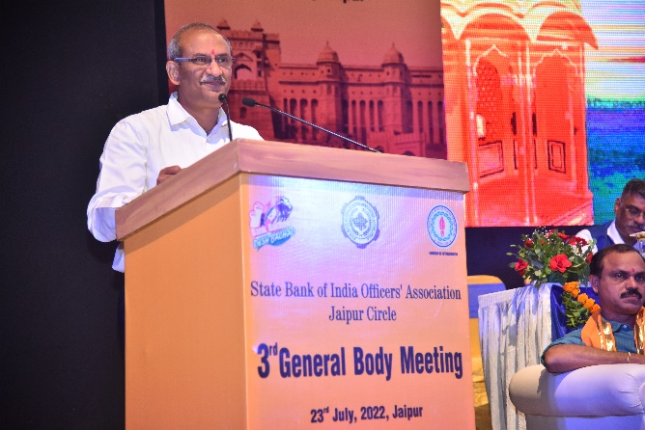
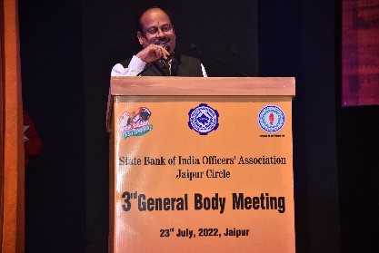
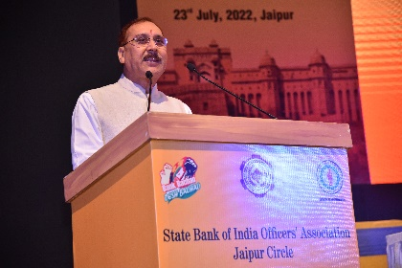
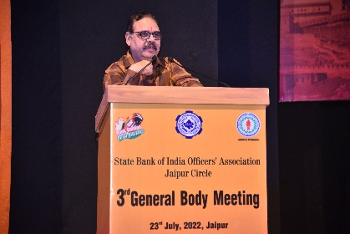
13. The undersigned congratulated the Chief General Manager of the Circle for his lucid speech highlighting the need for a humane approach and implementing work-life balance, and for not calling the officers to work on holidays. He said that issue of the absence of work-life balance is a matter of serious concern having an impact on industrial relations. He congratulated SBIOA Jaipur Circle for organizing the grand show of solidarity. He expressed happiness that momentum had been built up across the country to save public sector banks with #BankBachoDeshBachao movement, and it is of paramount importance to sustain it. He said that the banking fraternity, including pensioners, look up to our leadership. He touched upon various issues like 5 Day work week, family pension revision, pension updation, the quest for decent salary revision, and resolving the residual demands of the 8th Joint Note. He said that AIBOC is committed to a fair, reasonable wage revision with improvement in other service conditions.

14. Shri Prabhat Kumar Mishra, General Manager, NW-I touched upon the competition of Private Sector banks and payment banks, the concern on fraud and reputation risk and the need to avert them. He said that Association and Management should be real partners in progress and work together for the betterment of the bank and the employees.
15. Shri Hemant Karaulia, General Manager, NW-II, called upon all to make SBI retain its premier position. He expressed his concern about the effect of the merger of HDFC Bank with HDFC and the threat to the premier position. He urged all present to make sincere efforts to steer clear of all competition.
16. Shri Chandra Bhushan Kumar Singh, General Manager, NW-III, expressed his pleasure and welcomed the dignitaries to the Pink City Jaipur. He congratulated and thanked the officers’ fraternity for organizing the successful event. He expressed his concern about customer service and appeal to each officer for making the Jaipur Circle No-1 in the Customer Service parameter.
17. Shri Pradeep Sharma, General Manager, CAO, Chief Guest, expressed his happiness that the Circle had contributed a major share in the business and profit of the bank. He cautioned about the use of social media and the possible damage to the image of the bank. He thanked the Circle officers for achieving the best in all parameters and hoped to continue the same spirit and the imperative need for compliance.
18. Shri G K Jain, Chairman, Rajasthan Marudhara Gramin Bank, expressed his happiness that the circle association for inviting him and said that still member of the Circle Association, amidst huge applause. He welcomed all the delegates to explore the Maru Dhara.
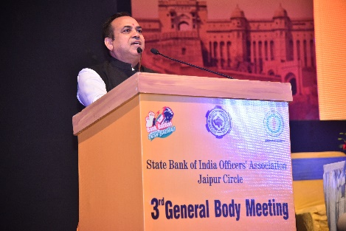
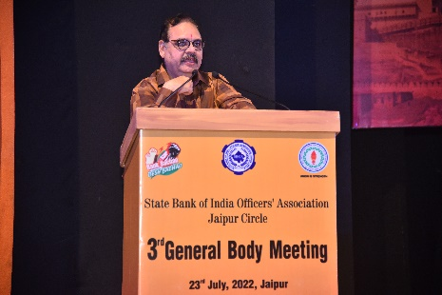
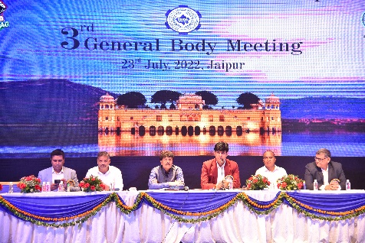
19. Comrades, the Annual General Meeting at Jaipur proved a grand event of passionate trade unionism and a show of strength and unity. The massive gathering amply demonstrated the urge of the officers to be united. This also provided us an opportunity to interact, understand and get connected to the ground, to forge a bonding so that the trade unionism and the legacy flourishes and proliferates for the common good of the officers' fraternity, working class and the bank as well.
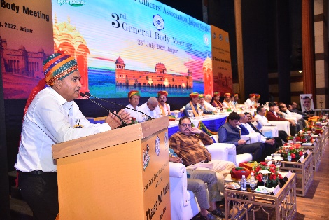

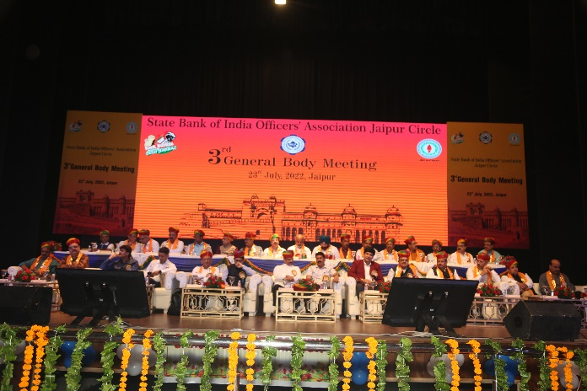
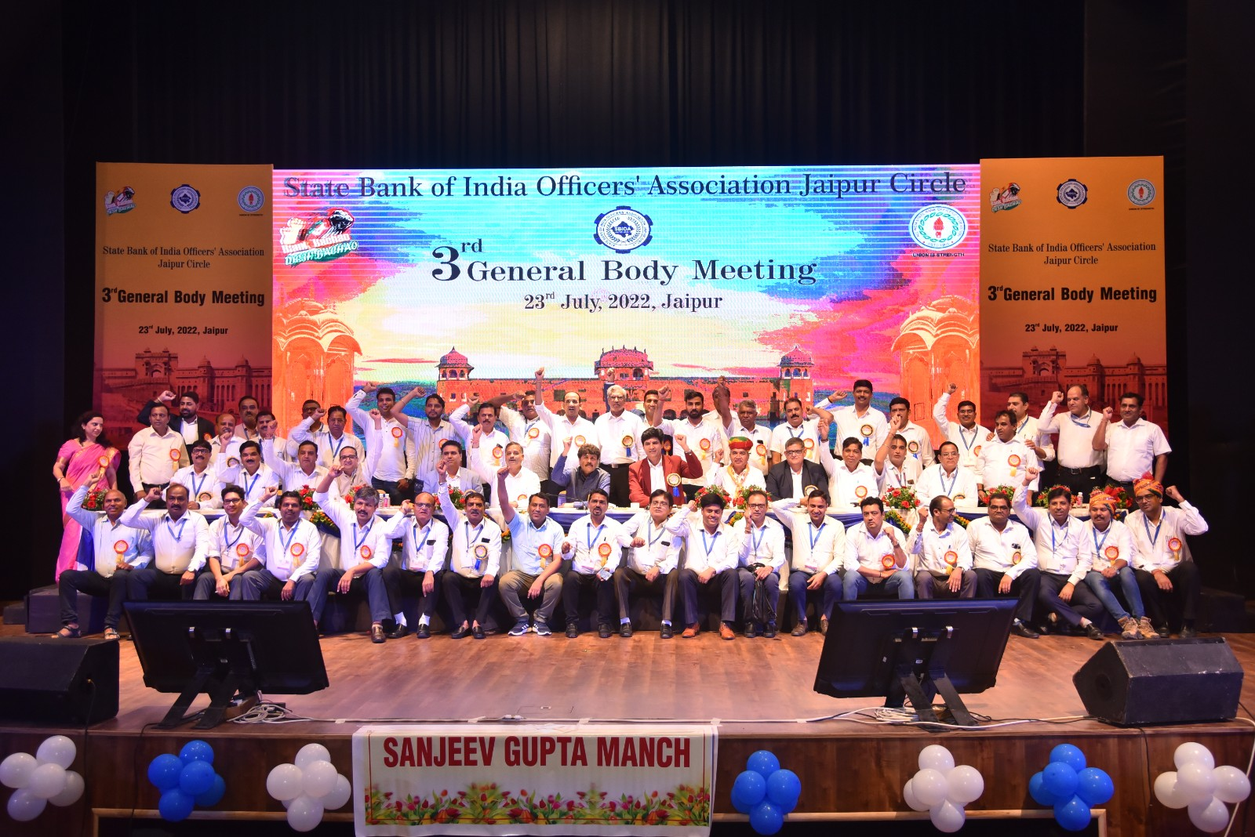
20. Sr. Vice President Sh. Mansingh Kachhawaha delivered the vote of thanks. The event was adroitly anchored by Com. Dharamveer Singh Bhatia and Com. Gopal Soni. We congratulate our affiliate, SBIOA (Jaipur Circle) and the vibrant leadership and membership who made the event a huge success.

With revolutionary greetings,

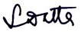
Yours Comradely,

Soumya Datta
General Secretary

At the Service of Members for more than 5 Decades
General Secretary: 9830044737, Kolkata-033-22130154, Fax: 033-22101684
Bengaluru: (Dir) 080 2221 1006 General: 25943132 Fax: 2221 4959
Email: aisbofbangalore@gmail.com Web: www.aisbof.org

